Employee’s Name: A.Amir john

Supplier Address: Cognizant Technology Solutions India Pvt Ltd

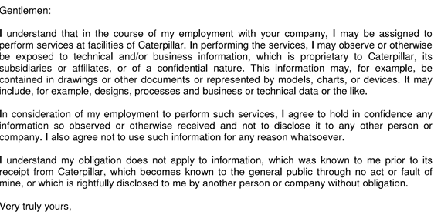

Signature:

Name: A Amir john

Date: 19-05-2020